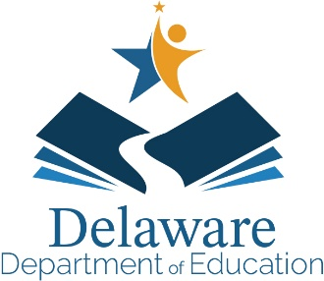

DEPARTMENT OF EDUCATION

Townsend Building

Mark A. Holodick, Ed.D.

Secretary of Education
(302) 735-4000
(302) 739-4654 - fax

401 Federal Street Suite 2
Dover, Delaware 19901-3639
http://education.delaware.gov

April 2023
Dear Parent / Guardian,
Your child participated in the Delaware System of Student Assessment (DeSSA) English Language Arts (ELA) and Mathematics summative tests during school year 2022-2023.
This is the last year (late July 2023) that you will receive printed score reports for your child via U.S. mail. If the printed report doesn’t arrive to your home by late August, there are two options for you to get the results:
- Contact your school and they will be able to print a report for you OR
- Use the unique Access Code provided to you by the school along with your child’s legal first name and date of birth, to log in to the DeSSA ELA and Mathematics Family Portal.

To view your child’s statewide assessment results:
1. Navigate to the DeSSA Family Portal located at https://de-familyportal.cambiumast.com.
2. Enter your child’s first name and date of birth and the unique Access Code provided by the school.
You can view your child’s overall test scores and the interpretive guide that can be downloaded and printed. The site also contains a glossary of assessment terms; a list of frequently asked questions (FAQs) with answers; performance levels and explanations of what they mean; and resources for you to use with your child.
Please note that your Access Code will be usable ongoing while you student is enrolled grades 3-8.
Please, contact your school and child’s teacher for more information about the family portal and how they can support your child’s continued learning.
Thank you for your investment in your child’s future!

Sincerely,
Theresa Bennett
Director of Office of Assessment & Accountability

